**PRACTICAL 3**

**Aim:** Write a program to demonstrate the use of Functions and Passing different types of arguments to function.

1. Program to demonstrate the use of Function.
2. Program to demonstrate the use of Return statement.
3. Program to demonstrate the use of passing arguments to functions.
4. Program to demonstrate the use of passing default argument.
5. Program to demonstrate the use of passing keyword argument.
6. Program to demonstrate the use of Scope of variables in functions.

**Program to demonstrate the use of Function:**

print("Program to Demonstrate the use of function")

def mike():

print("Hello")

print("CHANDIGARH UNIVERSITY")

mike()

**OUTPUT:**

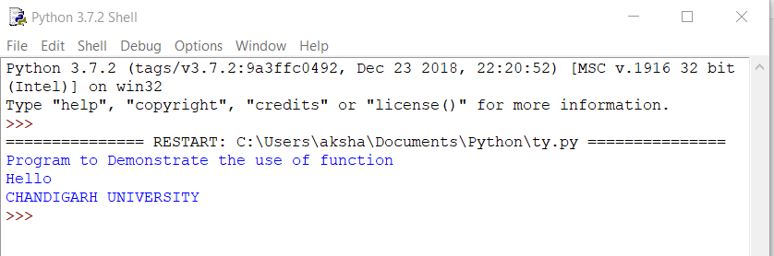

**Program to demonstrate the use of Return statement:**

print("Program to Demonstrate the use of Return Statement")

def hike():

x=int(input("Enter the value of x -"))

y=int(input("Enter the value of y -"))

z=x+y

return (z)

u= hike()

print(u)

**OUTPUT:**

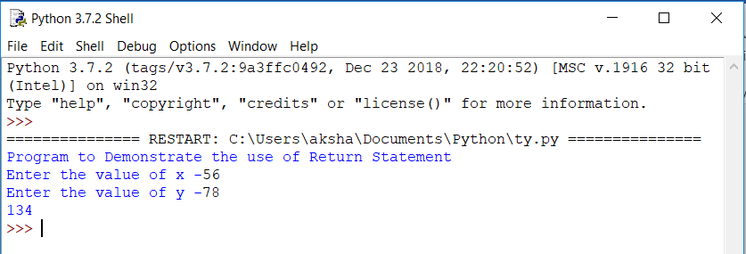

**Program to demonstrate the use of passing arguments to functions:**

print("Program to Demonstrate the use of Passing arguments to functions")

def sum(b,a):

t=sum(9,8)

Print t

print(b,a)

return(b+a);

Print (b,a)

t=sum(9,8)

print(t)

Return(b+a)

**OUTPUT:**

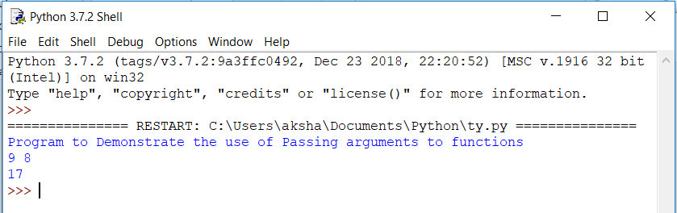

**Program to demonstrate the use of passing default argument:**

print("Program to Demonstrate the use of Passing default arguments")

def default(x=10,y=41):

print(x+y)

default()

**OUTPUT:**

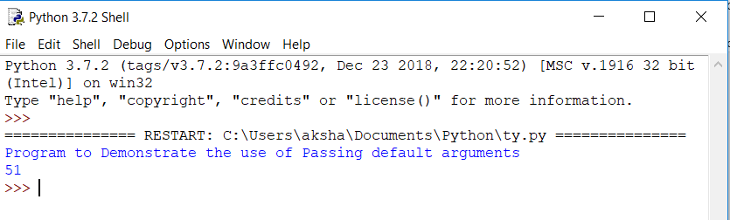

**Program to demonstrate the use of passing keyword argument:**

print("Program to Demonstrate the use of Passing keyword arguments")

def keyword(id="17BCS2774"):

print("keyword function")

print(id)

keyword()

**OUTPUT:**

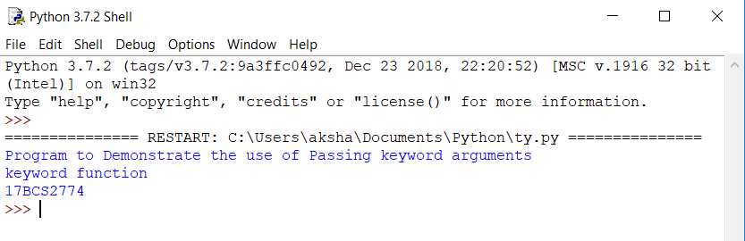

**Program to demonstrate the use of Scope of variables in functions:**

print("Program to Demonstrate the use of Scope function")

a=20

def scope():

b=13

c=a+b

print("scope function calling")

print(c)

scope()

**OUTPUT:**

